**Significance of the work**

The project aims to provide DNA-encoded library screening to the consortium. This will provide an alternative source of hit finding for novel targets and a potential platform for finding hits against future targets in a rapid and efficient manner.

**Significant project-generated resources**

Selection data from 3 million compounds against EV71A 3C have been provided to the consortium. Data for 2 further targets is imminent. Compounds from the selection have been prioritized for synthesis.

**A. Specific Aims for the MP/DRP**

The Specific Aims have not been modified from the original, competing application.

**B. Studies and Results**

A poised library for derivatization as a covalent library targeting viral proteases has been prepared. This work was paused pending supply of protein from the consortium. The first proteins arrived at the end of February.

The initial step was to choose which warhead is stable and compatible with DEL chemistry. The designed peptide library allows installation of warheads in cycle 3.

The plans also included testing the stability of different warhead classes through qPCR. Therefore, 6 full DNA sequences were prepared ready to attachment of the relevant warheads. However, before running the step, the warheads should be validated first for DMT-MM amide coupling with MS and making sure that the warhead was installed correctly.

The synthesised library (PL-16) was based on 2 cycles of forward amide coupling. The synthesis stopped in the step of Fmoc deprotection in third cycle. This to keep the library stable pending selection of suitable warheads, which is to be provided by the consortium.

3 million encoded compounds have been screened against 3 targets and data for EV71A 3C have been provided to the consortium. Enrichment data and selected hits are shown in the table. Hit molecules have been prioritised for synthesis.

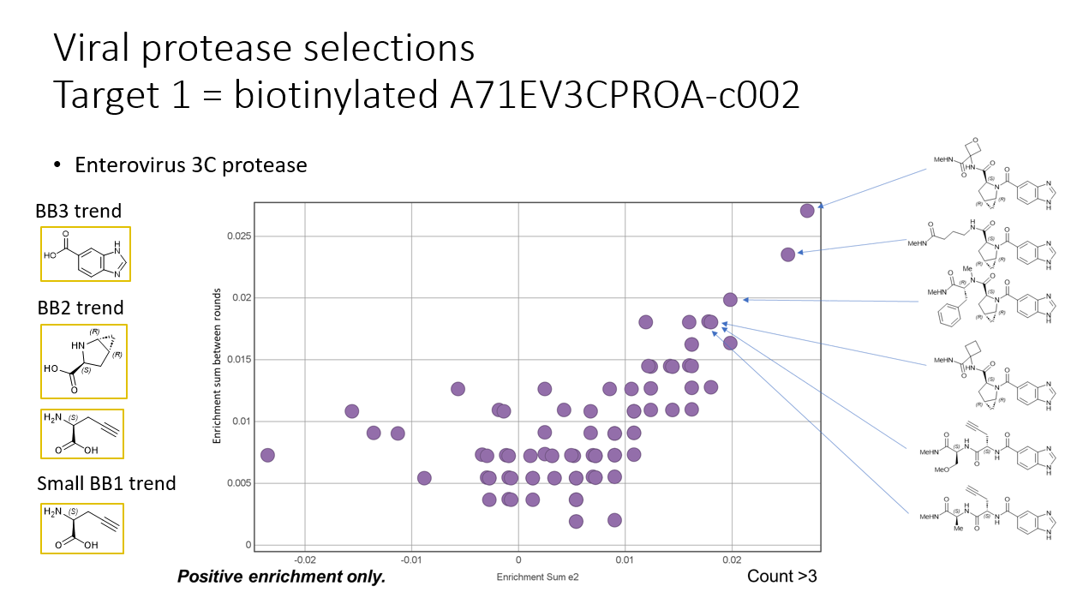

Preliminary results against Enerovirus A 2A protease show similar features but different compounds are enriched. This gives confidence in the selections and suggests the approach can successfully used to find potent and selective hits.

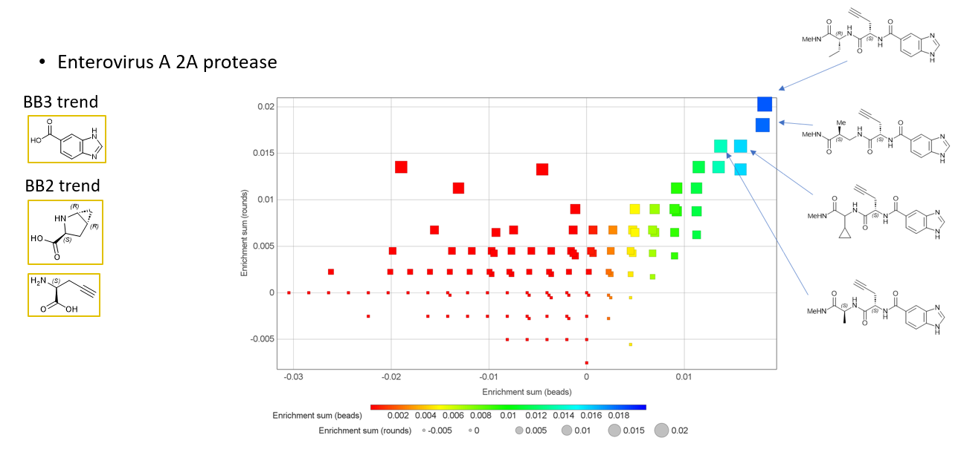

Selected compounds are being synthesised for off-DNA validation.

Selections against Dengue type II NS2B-NS3 look less promising and have thus far failed to reveal enriched features, but further libraries will be screened in due course.

**C. Significance**

The screens provide novel start points for drug discovery. Because DELs allow large numbers of structurally related compounds, synthesised in matrices, it is possible that potent compounds can be found directly from screening. It is also really fast, requiring pmol quantities of protein and returning results in 2-3 weeks. This would provide ideal technology for having a rapid and versatile response to emerging viral threats. Our initial results suggest that leads can be found in our existing DELs and have provided start points for EV71A 3C. As well as leads for the project, this also serves as a proof of concept that protease hits can be found using this approach and that our libraries are relevant.

**D. Plans**

The funding for the award finishes in April. We will complete screening of the 3 proteins we have been supplied. The Waring group is amenable to providing future screens subsequently, resource permitting and happy to discuss future collaborations.

**Training and Professional Development (For Mentored Projects only)**

NA